DM18
Unreal Tournament III
Document Date: 02/18/09
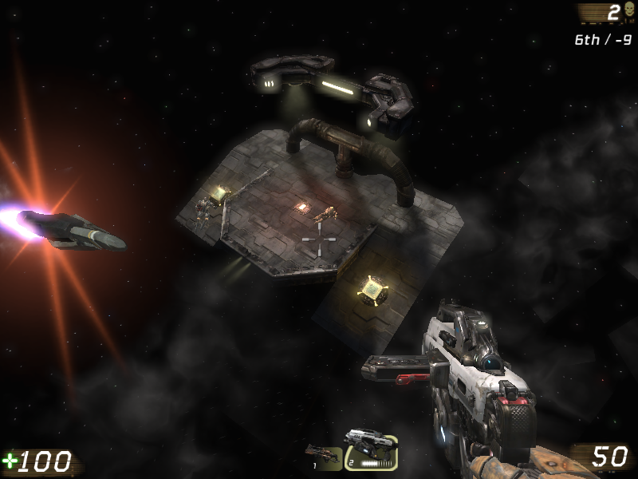

Designer: Dan Brennan
Intended Level Delivery Date: 03/06/09
Table of Contents
Document Revisions Table 3
List of Figures 4
Quick Summary 5
Gameplay Overview 6
General Game Flow 6
Major Elements 7
Major Objectives 7
Environmental Hazards 7
Technical Overview 9
Mission Location 9
Gametype(s) 9
Items/Powerups 9
Difficulty (1 - 5) 10
Mission Metrics 10
Level Details 11
Theme/Mood 11
Special Character/Vehicle Needs 11
Gameplay Mechanics 12
Backstory/History 12
Visual References 13
Terrain/Vegetation 13
Models/Architecture 13
Textures/Lighting 17
Characters/Vehicles 19
Maps 20

Document Revisions Table
VERSION | DESCRIPTION | UPDATED BY | DATE
v1.0 | Initial version of document | Dan Brennan | 02/18/09

List of Figures
Figure 1 – Unreal Tournament III logo 5
Figure 2 – Unreal Tournament III combat-based gameplay 5
Figure 3 – General flow across floors 1 and 2 depicted in red 6
Figure 4 – General flow across floors 3, 4 and 5 depicted in red 6
Figure 5 – Jump pads used plentifully for high-flying action 7
Figure 6 – Original Quake III: Arena DM17 map 8
Figure 7 – Recent Unreal Tournament III DM17 remake 8
Figure 8 – Unreal Tournament III’s Rocket Launcher, Stinger Minigun and Link Gun (background) depicted here 9
Figure 9 – Unreal Tournament III characters in action 11
Figure 10 – Win the battle for control of the satellite or suffer its destructive power! 12
Figure 11 – Color palette 13
Figure 12 – Satellite orbiting Earth concept 13
Figure 13 – Alternate satellite concept 14
Figure 14 – Planet/moon concepts 14
Figure 15 – Unreal Tournament III sun static mesh 15
Figure 16 – Satellite weapons system concept 15
Figure 17 – Space-platform architecture concept 15
Figure 18 – Metallic space-technology static mesh 16
Figure 19 – Metallic space-platform/surface static mesh 16
Figure 20 – Space skybox concept 17
Figure 21 – Metallic platform texture concept 17
Figure 22 – Alternate metallic platform texture concept 18
Figure 23 – Potential Unreal Tournament III metallic texture 18
Figure 24 – Sterile white light concept 19
Figure 25 – Standard Unreal Tournament III multiplayer characters only 19
Figure 26 - Two-dimensional view, floors 1 and 2 20
Figure 27 – Two-dimensional view, floors 3, 4 and 5 21
Figure 28 – Three dimensional view, top down 22
Figure 29 – Three dimensional view, third floor side 22
Figure 30 – Three-dimensional view, second floor side 23
Figure 31 – Three-dimensional view, first floor side 23
Figure 32 – Three-dimensional view, first and second floor center 24
Figure 33 – Three-dimensional view, third, fourth and fifth floors center 24
Figure 34 – Three-dimensional view, first floor outer perimeter (1 of 4 rotating sniper platforms) 25

Quick Summary
Set on a satellite traveling through space, DM18 features fast-paced, jump pad intense, high-flying action.

This sixteen-player Unreal Tournament III DeathMatch map takes place on a satellite orbiting the earth. The satellite moves imperceptibly across the lit side of the planet as the battle rages on. The play-space partially mimics the classic Quake 3 Arena “DM17” level, with a modified, mirrored take on that layout. The level accommodates 16 players, and features most of the standard weapon types found in Unreal Tournament III.

Figure 1 – Unreal Tournament III logo

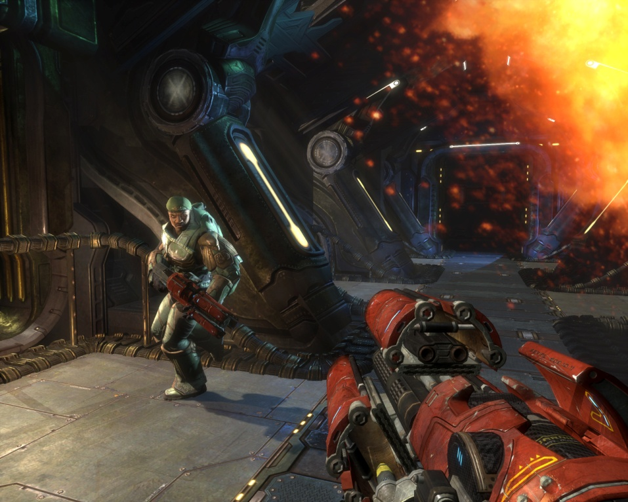
Figure 2 – Unreal Tournament III combat-based gameplay

Gameplay Overview

General Game Flow
DM18 features a straight back-and-forth flow across the first floor, a figure-8 across the second and third floors individually, and a circular flow around the outer perimeter (inherent in the rotation of the outer platforms). Between levels, jumping on jump pads and falling down from upper levels provide an additional layer of up-and-down flow. This complex flow keeps the action at a consistently high-level, as encounters spring up perpetually.
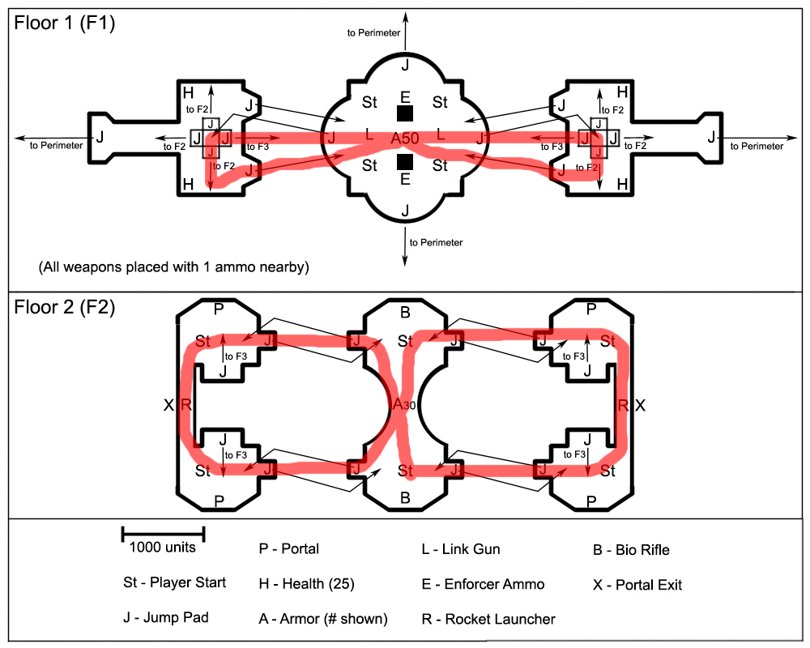
Figure 3 – General flow across floors 1 and 2 depicted in red
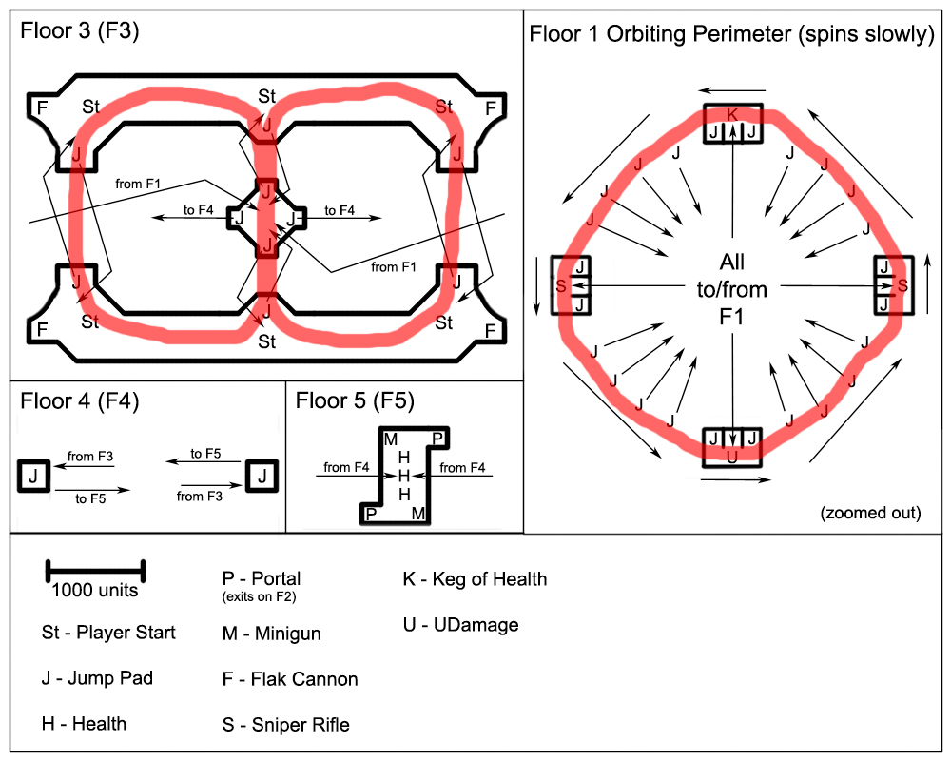
Figure 4 – General flow across floors 3, 4 and 5 depicted in red

Major Elements
- Jump-pad intense gameplay
- Multiple portals mix up game-flow
- Rotating perimeter platforms/jump-pads (wow moment)
- Open space with uninterrupted flow
- Readily appealing to fans of DM17 fast-paced gameplay

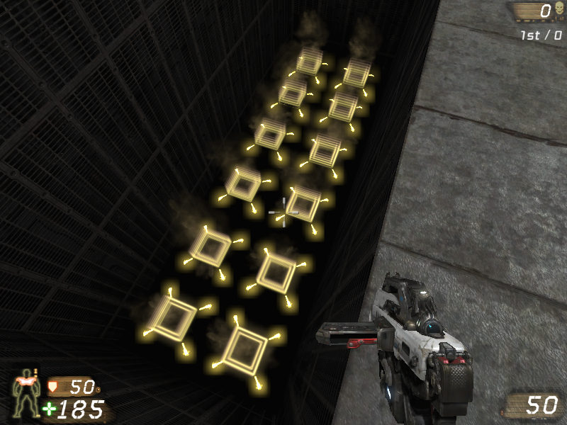
Figure 5 – Jump pads used plentifully for high-flying action

Major Objectives
As per DeathMatch rules, the first player to reach 20 kills wins. Players cannot lose solely due to repeated death; they continue to respawn as long as no player has reached 20 kills. Taking advantage of high ground, carefully timing trips to the outer perimeter and constantly moving improves the player’s chances of success.

Environmental Hazards
A fall from any platform or a poorly timed/aimed jump from a jump-pad sends the player tumbling to their death. No other hazards exist.

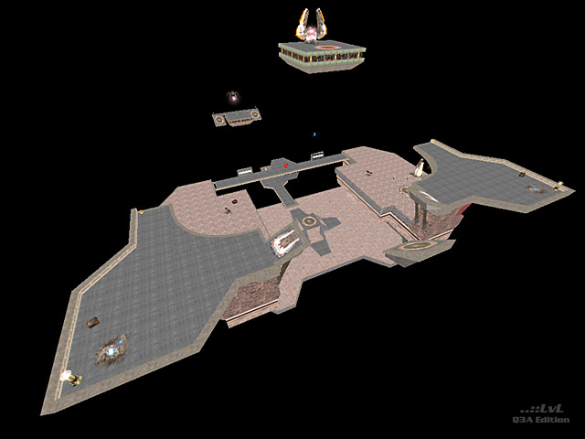
Figure 6 – Original Quake III: Arena DM17 map

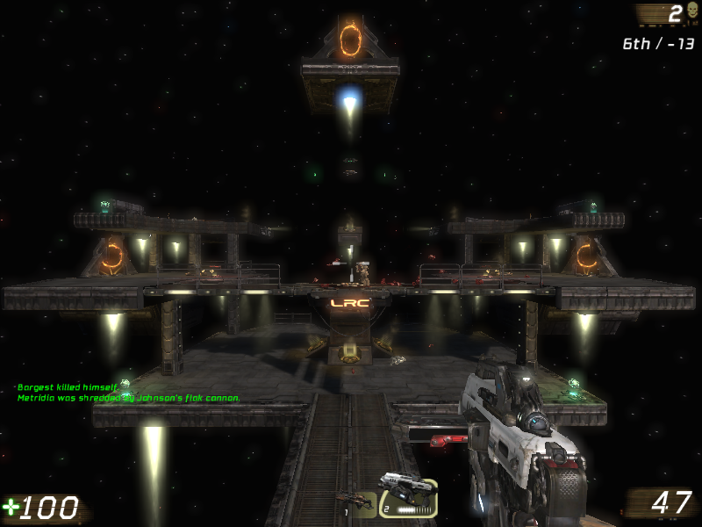
Figure 7 – Recent Unreal Tournament III DM17 remake

Technical Overview

Mission Location
- Setting: A massive satellite orbiting Earth
- Time of Day: Afternoon on section of Earth directly below (sun within view)
- Season: N/A
- Weather: N/A

Gametype(s)
- DeathMatch
  - Min Players: 8
  - Ideal Players: 12
  - Max Players: 16

Items/Powerups
Weapons available include the default Impact Hammer and Enforcer, the Sniper Rifle, Bio Rifle, Link Gun, Stinger Minigun, Flak Cannon and Rocket Launcher. Available health includes 7 units worth 25 each and 25 units worth 5 each (300 total health), while available armor includes one unit worth 50 and one unit worth 30 (80 total armor). Powerups include the Keg O’ Health and the UDamage powerup.
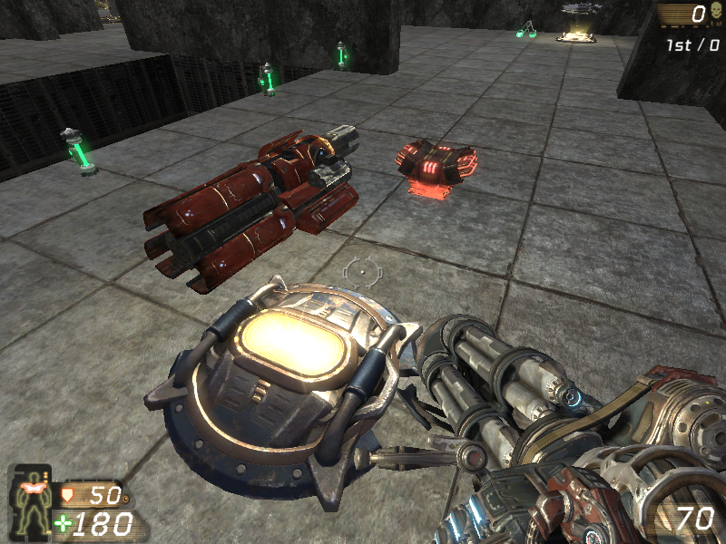

Figure 8 – Unreal Tournament III’s Rocket Launcher, Stinger Minigun and Link Gun (background) depicted here

Difficulty (1 - 5)
The level carries an approximate difficulty of 4 out of 5, due to the high risk of falling and the dangerous scenarios into which the jump-pads may thrust the player.

Mission Metrics
- Play Time: 5-10 minutes
- Physical Length/Area: approximately 12,000 by 12,000 units measured from furthest points (actual surface area considerably less)
- Visual Themes: 1 – outer space in close proximity to earth

Level Details

Theme/Mood
DM18 carries the theme of a lonely, stranded piece of human technology orbiting the Earth in complete silence, until a fast and raging battle takes place across its metallic platforms. The level should impress upon the player a feeling of cold solitude, populated only falsely by rampant death. Methods of conveying the theme/mood include:

- Earth spinning slowly at a distance (to highlight civilization as distant)
- Stars as far as the eye can see in all directions
- Other planets at differing distances
- Cold, metallic mechanisms set up throughout the play-space
- No other satellites in view

Metal textures look almost unworn, giving the sense that no one has touched this satellite since its launch. Sterile white/grey light also lends to this feeling. The absence of additional music or sound effects (outside of the existing Unreal Tournament III combat sounds) contributes to the feeling of lonely silence.

Special Character/Vehicle Needs
This map uses the standard multiplayer characters.

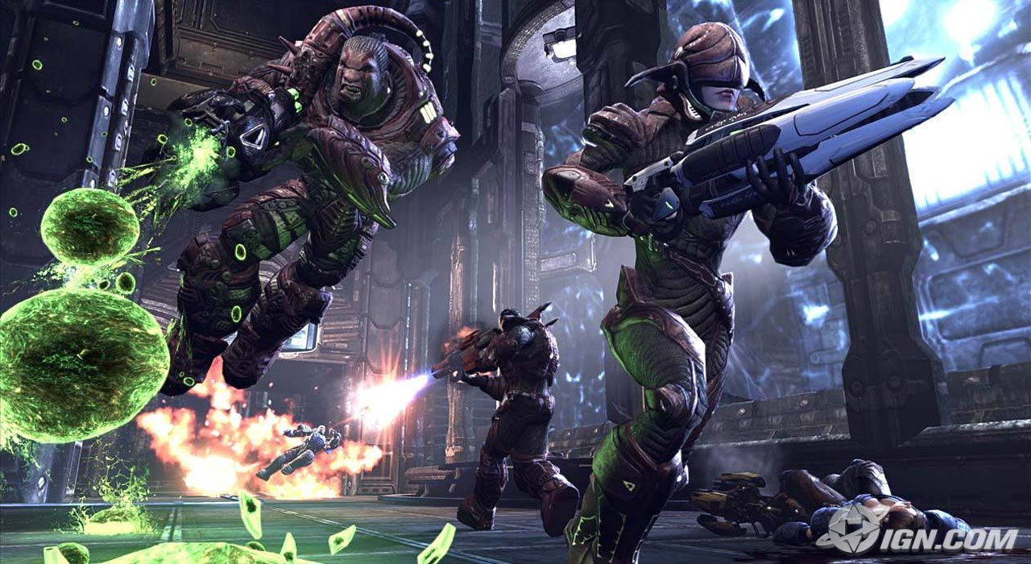

Figure 9 – Unreal Tournament III characters in action

Gameplay Mechanics
- Prerequisite Skills – Basic movement, jumping, aiming and shooting basics, understanding of UT3 weapons and pickups
- Skills Learned – Advanced sniping on fast-moving targets, use of high-ground tactics, jumping at falling risk during combat, advanced defensive movement, advanced jump-pad utilization

Backstory/History
This massive modern American satellite – assembled a few short years ago and launched shortly afterwards – quietly orbits the Earth. Unknown to the foreign nations of the planet below, the satellite serves the dual functions of surveillance and, if ever necessary, dropping a precision laser beam down on America’s enemies. For years, the Americans found no situation dire enough to warrant activating the weapons systems on the satellite. Otherwise undetectable by most existing tracking technology, the satellite continued in its purpose uninterrupted… until now.
The satellite’s true purpose became general knowledge among the major powers on Earth when its laser system was used to target and obliterate a foreign terrorist training camp. Word spread quickly with great fear of the weapon’s power and potential uses, and the foreign powers below decided individually that they must take action. A mad dash to wrestle control of the satellite away from the American government ensued. Combat-ready astronauts with advanced armor and weaponry shuttled up to the orbiting technology, only to find that many others had the same intentions in mind. That an American representative had already arrived to defend the satellite surprised them even more.
The battle promises to be one for the ages…

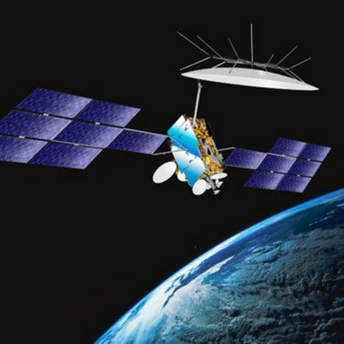
Figure 10 – Win the battle for control of the satellite or suffer its destructive power!

Visual References

Figure 11 – Color palette
The color palette features shades of gray for metal, blues and whites for earth, bright colors for the sun, black for space, and combinations of all of these for the satellite and its mechanisms.

Terrain/Vegetation
N/A – Outer-Space Environment

Models/Architecture

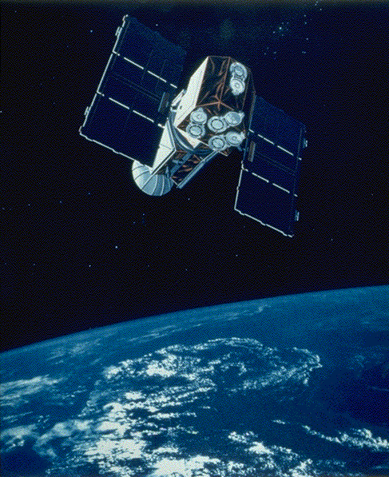
Figure 12 – Satellite orbiting Earth concept

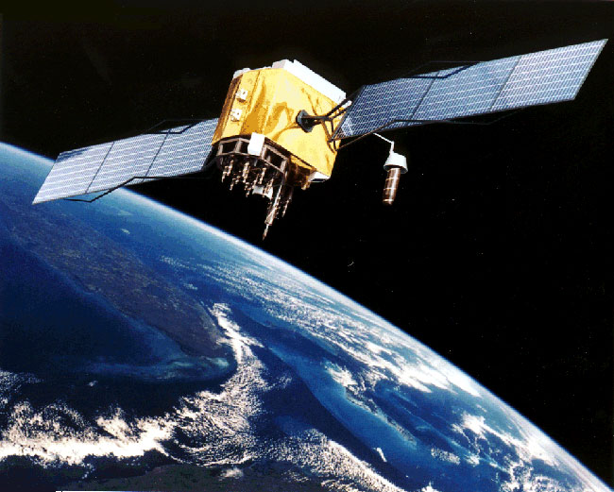
Figure 13 – Alternate satellite concept

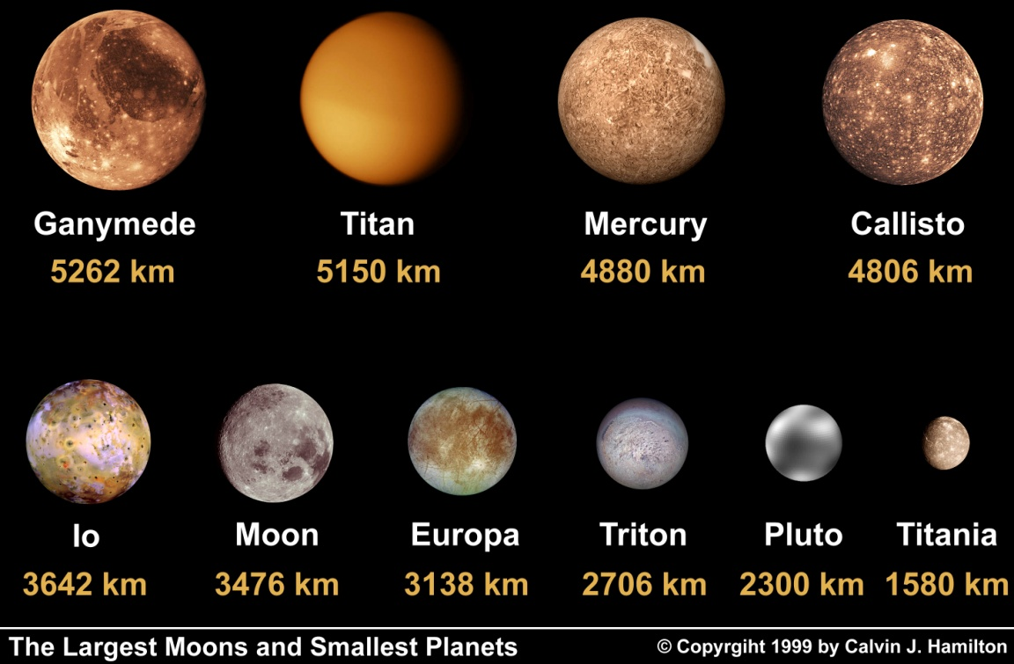
Figure 14 – Planet/moon concepts

Figure 15 – Unreal Tournament III sun static mesh
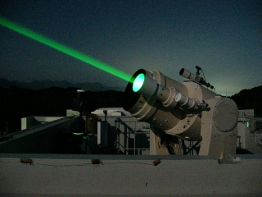
Figure 16 – Satellite weapons system concept

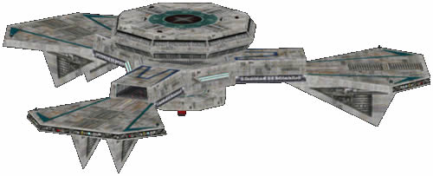
Figure 17 – Space-platform architecture concept

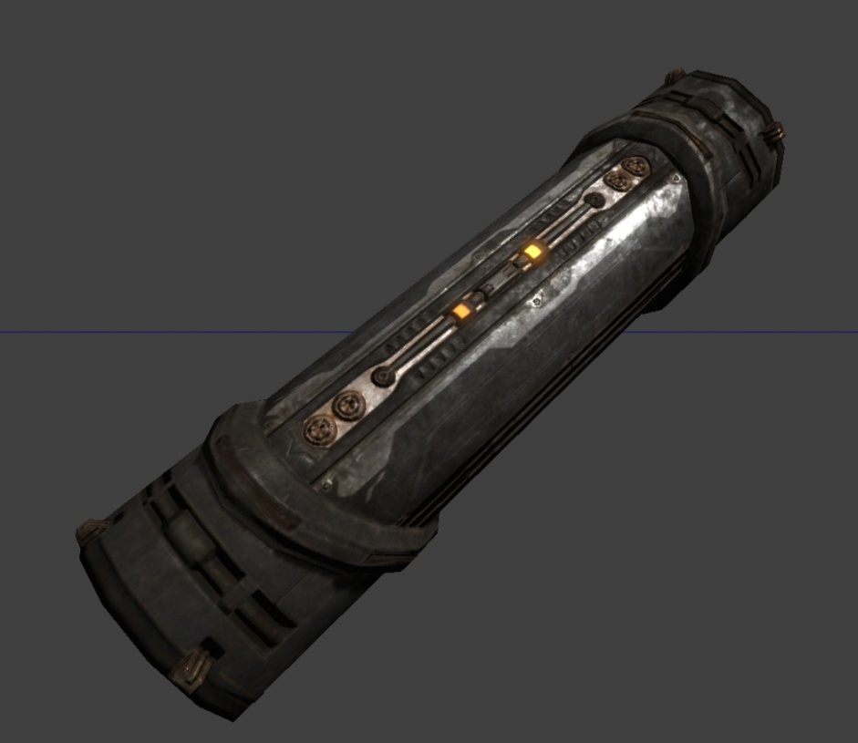
Figure 18 – Metallic space-technology static mesh

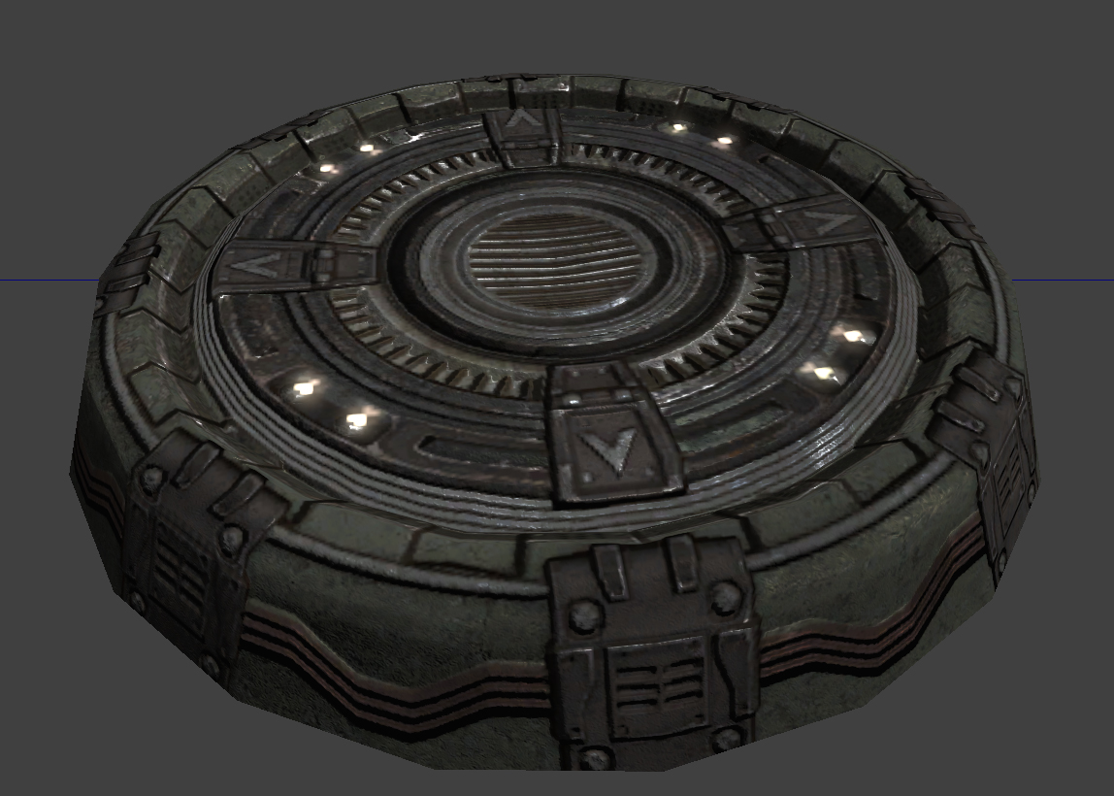
Figure 19 – Metallic space-platform/surface static mesh

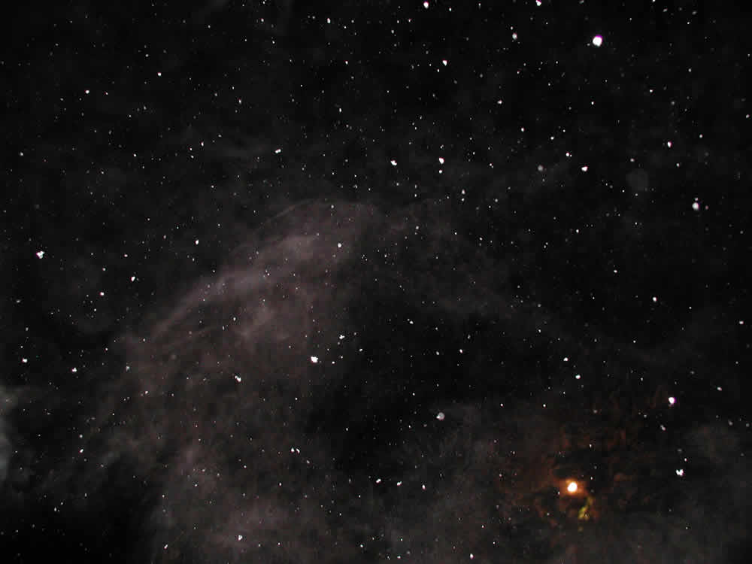
Figure 20 – Space skybox concept

Textures/Lighting

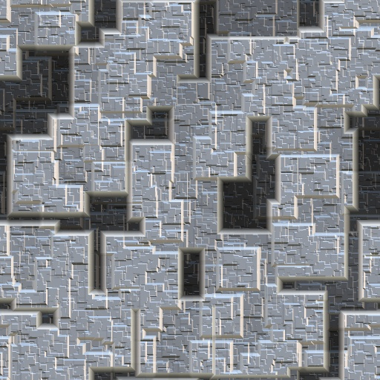
Figure 21 – Metallic platform texture concept

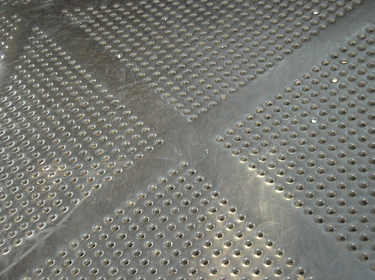
Figure 22 – Alternate metallic platform texture concept

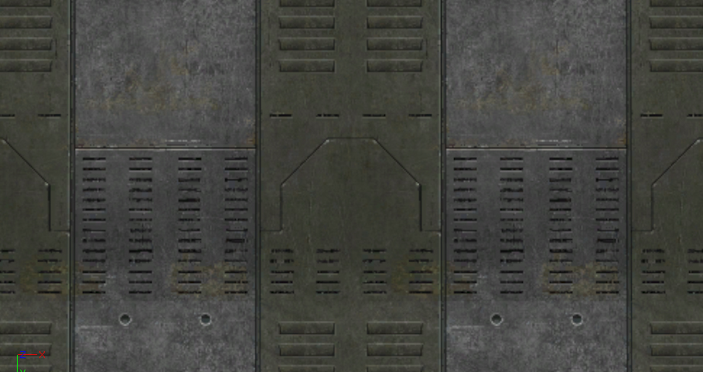
Figure 23 – Potential Unreal Tournament III metallic texture

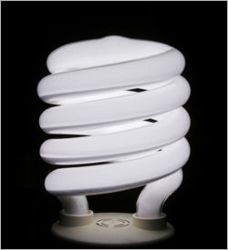
Figure 24 – Sterile white light concept

Characters/Vehicles

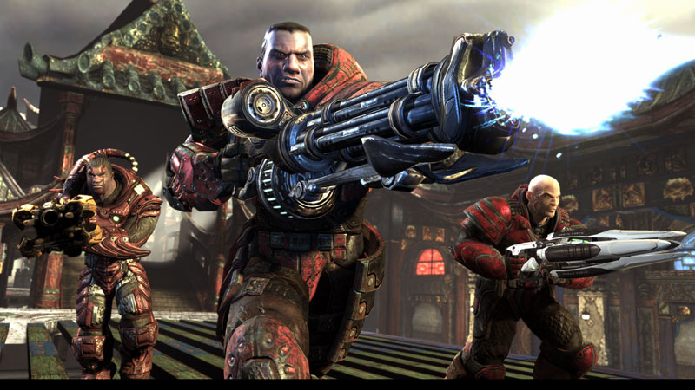
Figure 25 – Standard Unreal Tournament III multiplayer characters only

Maps

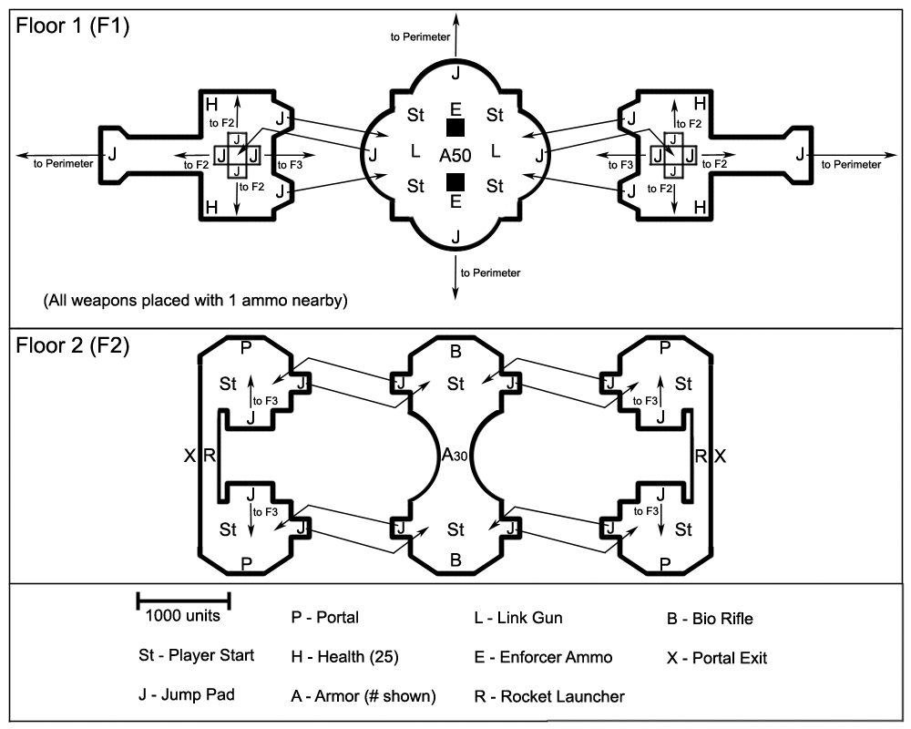
Figure 26 - Two-dimensional view, floors 1 and 2

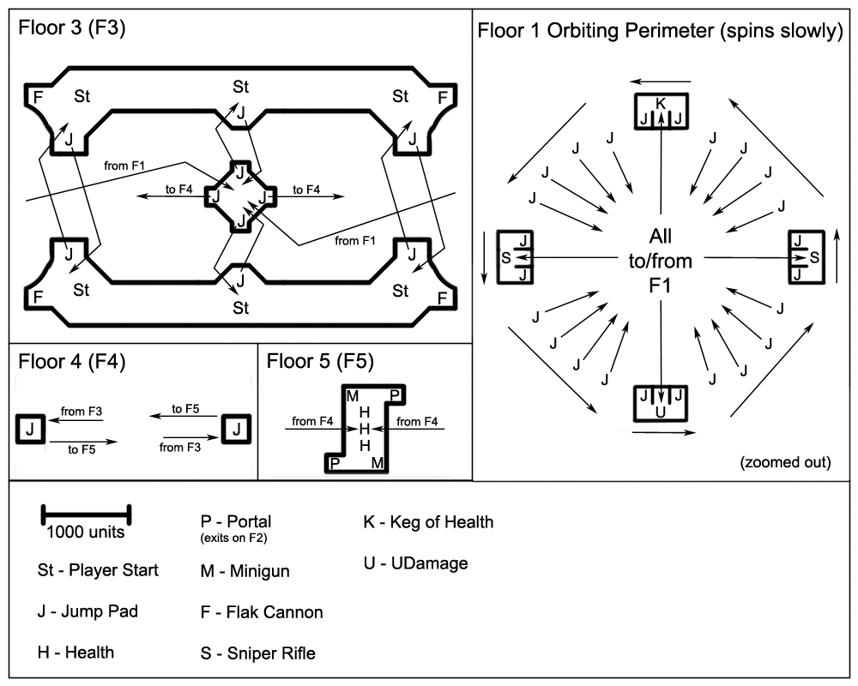
Figure 27 – Two-dimensional view, floors 3, 4 and 5

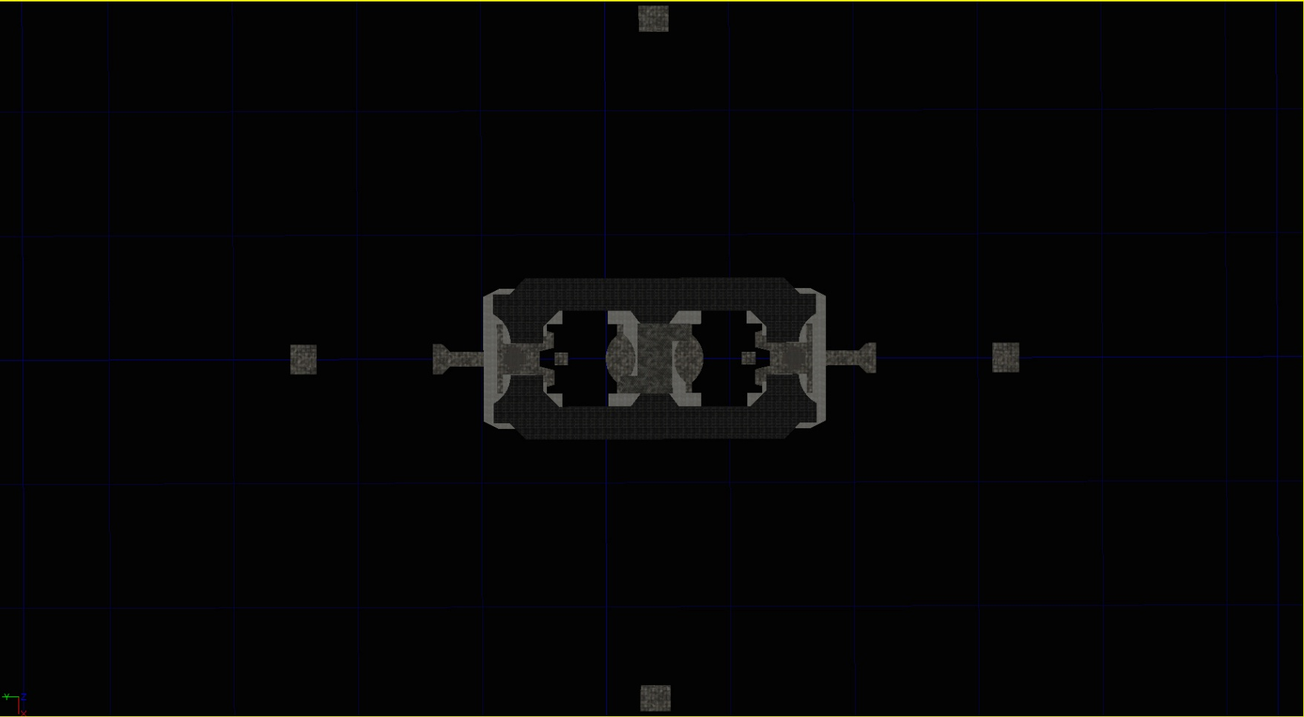
Figure 28 – Three dimensional view, top down

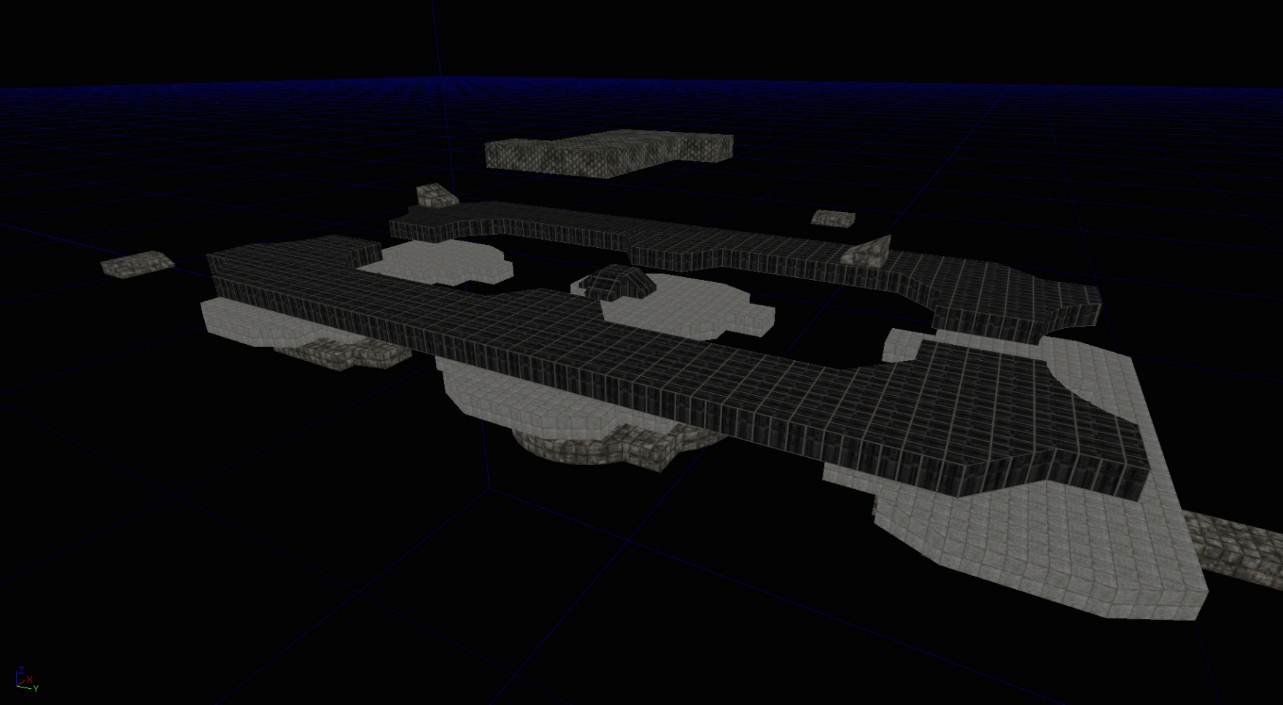
Figure 29 – Three dimensional view, third floor side

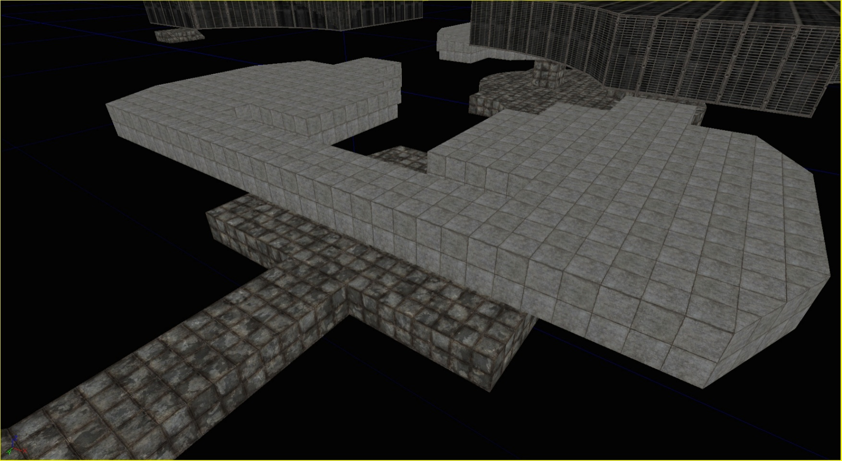
Figure 30 – Three-dimensional view, second floor side

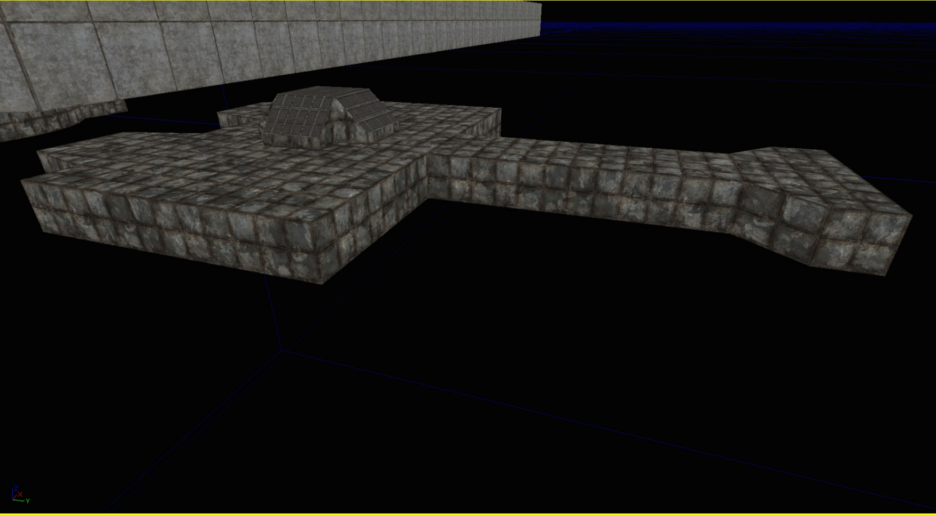
Figure 31 – Three-dimensional view, first floor side

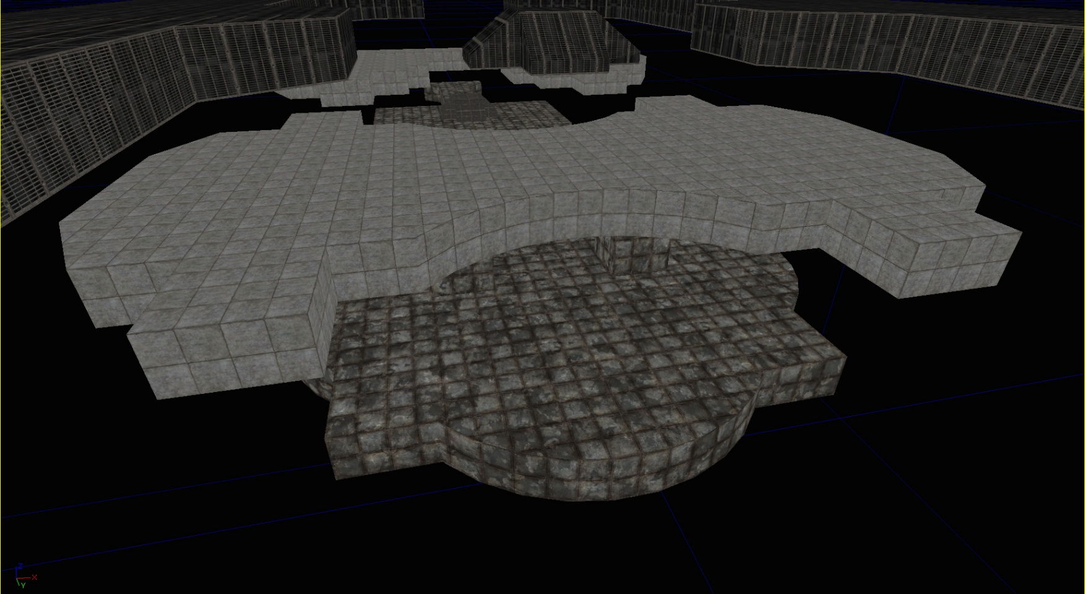
Figure 32 – Three-dimensional view, first and second floor center

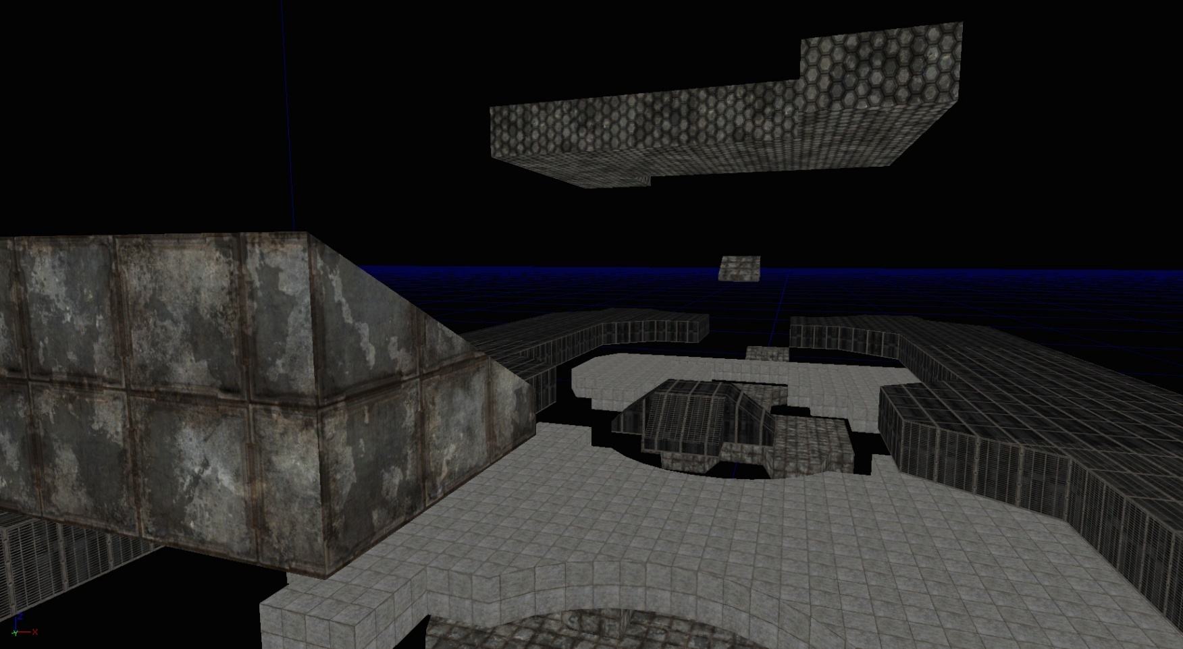
Figure 33 – Three-dimensional view, third, fourth and fifth floors center

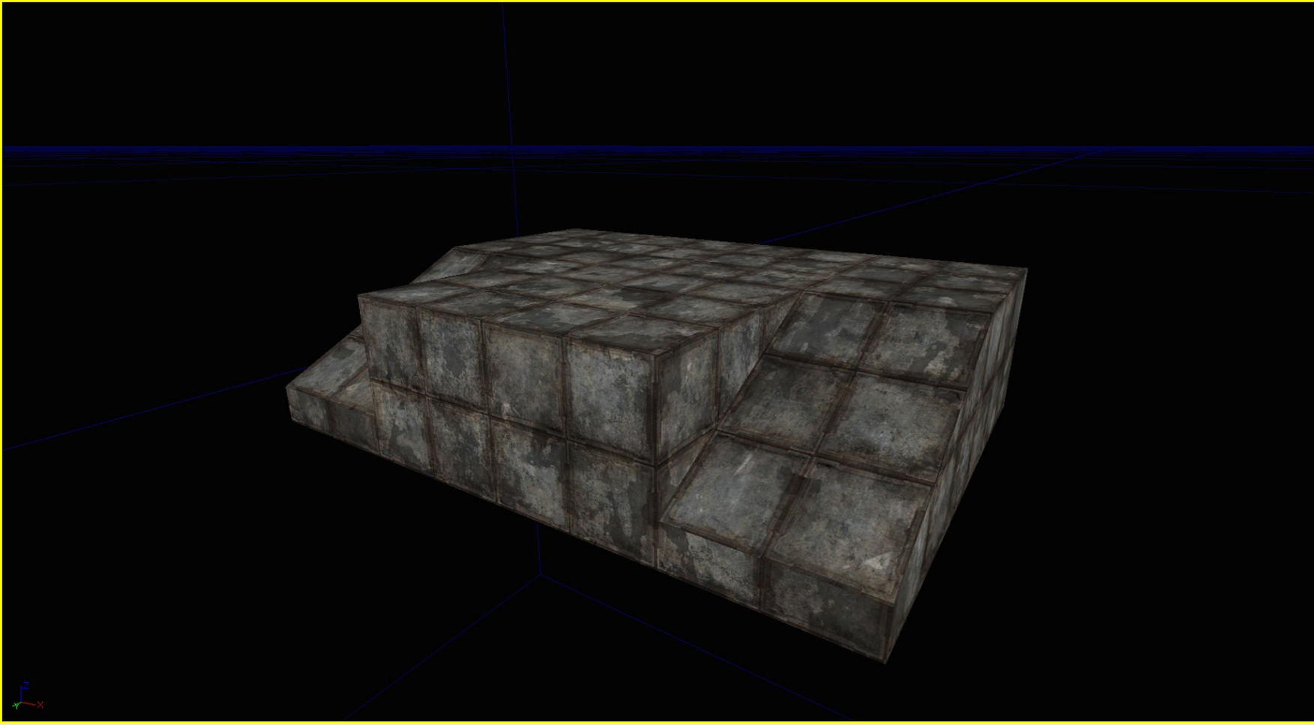
Figure 34 – Three-dimensional view, first floor outer perimeter (1 of 4 rotating sniper platforms)

